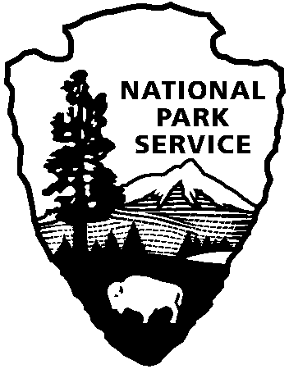

National Capital Parks - East
1900 Anacostia Drive SE
Washington, D.C. 20020
https://www.nps.gov/pisc/index.htm

(202) 690-5185
National Park Service
U.S. Department of the Interior

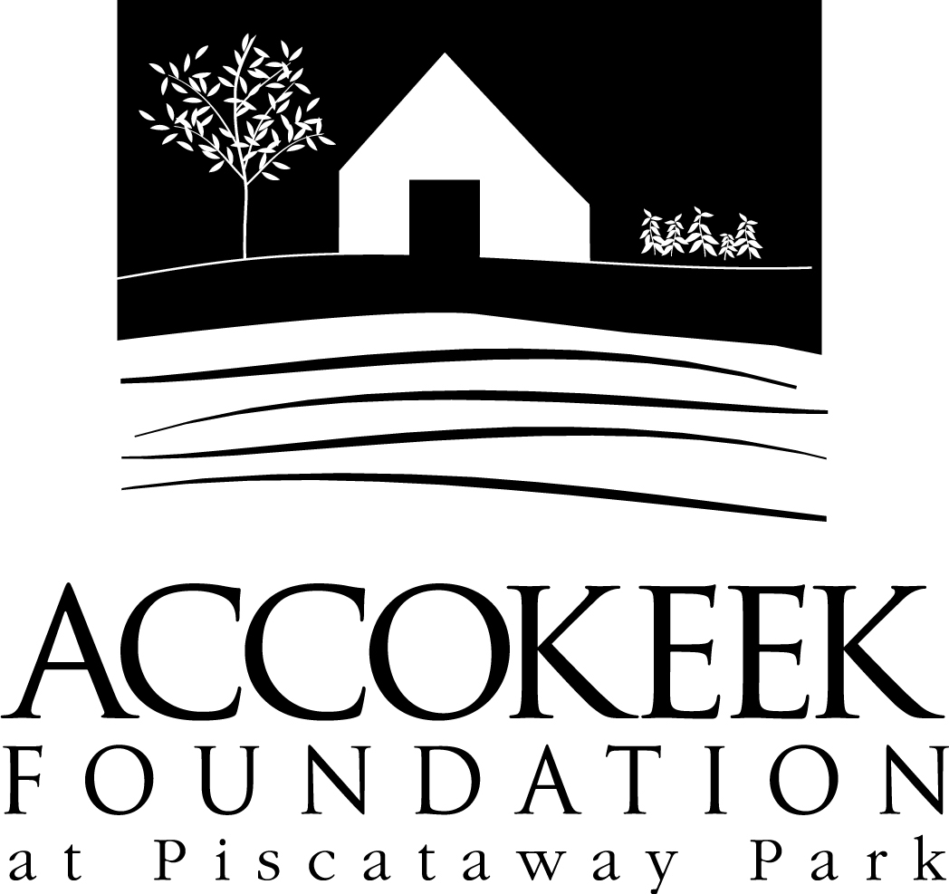

Position Title: Bluebird Monitor

About the Foundation:
By blending history, ecology, economics and conservation, the Accokeek Foundation strives to teach land stewardship and sustainable use of natural resources, as well as interpret the natural and cultural heritage of the Tidewater Potomac. The foundation’s mission is to cultivate passion for the natural and cultural heritage of Piscataway Park and commitment to stewardship and sustainability. The National Colonial Farm and other Foundation activities exemplify the agricultural, preservation and conservation goals that are at the core of the Foundation’s mission and serve as an outdoor classroom to further the educational programs that are key to its success. In partnership with the National Park Service, the Accokeek Foundation stewards a 200-acre portion of Piscataway Park and preserves the view directly across the Potomac River from Mount Vernon.

About National Capital Parks - East:
The administrative National Park Service unit of National Capital Parks – East (NACE) contains thirteen park units and parkways, including Piscataway Park. The overall unit consists of 98 locations and more than 8,000 acres of recreation areas, historic homes, natural areas, farms, parkways, historic forts, archeological sites, and private properties. The sites provide important green and recreation space amongst dense urbanization and educate visitors through stories and the historical information related to the area.

About the Citizen Science Program:
The citizen science program is part of the Accokeek Foundation’s stewardship of Piscataway Park. Many visitors appreciate the beauty of the park without realizing their important role in preserving this incredibly biodiverse set of ecosystems. At the Accokeek Foundation, we seek to help protect and preserve the natural world while constantly growing our understanding of and modifying our impact on the world around us. As we document and catalog the incredible species around us, we are helping to advance science and grow our understanding of the direct correlation between our everyday actions and the direct responses seen in nature. Our Citizen Science Program includes Bluebird Monitoring, Invasive Plants Monitoring, Invasive Plants Removal, and Bioblitz programming.

Position Summary and Purpose:
The Bluebird Monitor Volunteer position was created to help protect and document our incredible flock of Eastern Bluebirds living on the 200 acres of National Park land stewarded by the Accokeek Foundation. Eastern Bluebirds are no longer a deep concern in relation to the threatened and endangered list, but they are a beautiful species that faces habitat loss from a variety of forces. As part of our citizen science programming, Bluebird Monitoring helps to document the incredible creatures living on our land, while also educating the general public about the biodiverse ecosystem they impact every day.

Description:
The Eastern Bluebird is one of the most vibrant critters you will meet on a visit to Piscataway Park, but unfortunately they face fierce habitat competition from invasive bird species. The Bluebird Monitor volunteer program monitors a trail of 20 Bluebird Boxes to ensure that these native cavity nesters have a safe place to build their nests each year. Volunteers protect the nests from pests and predators, while also collecting important data on egg and hatchling numbers.

Description of Duties:
- Monitor 20 Bluebird Boxes, March - August
- Mend/prevent predator damage and document losses
- Document Data using online data log
- Report concerns to Program Lead
- Educate visitors about the value of protecting these beautiful birds

Qualifications:
Monitors will receive training each season on best practices of nest monitoring. They will learn how to deal with pests and predators, how to make basic fixes to boxes, and how to collect and report data. Monitors will also need to engage with the general public in a courteous and knowledgeable way, since we are a public park open from dawn to dusk.

Time Requirements:
This position requires a commitment of volunteering from March-August, featuring flexible weekly shifts. Boxes are checked no more than twice a week.

Benefits:
Volunteers will also receive a one-year family membership to the foundation which includes discounts on classes and events, invitations to “Friends Only” events, and a 10% discount at the museum gift shop and visitor’s center.

Volunteers will also be enrolled in the National Park Service – wide Volunteers – In – Park (VIP) program by signing Volunteer Service Agreements. The VIP program protects those volunteering on National Park Service land in case of accident or injury through the Federal Employees’ Compensation Act and the Federal Tort Claims Act. Additionally, for every 250 hours served, volunteers are eligible to receive the America the Beautiful interagency pass which covers entrance fees to more than 2,000 federal recreation sites, including national parks and wildlife refuges, for one year.

Supervisor:
Kate McGowan, Museum Educator

To Apply:
Please contact Kaylin Beach at volunteers@accokeek.org.

