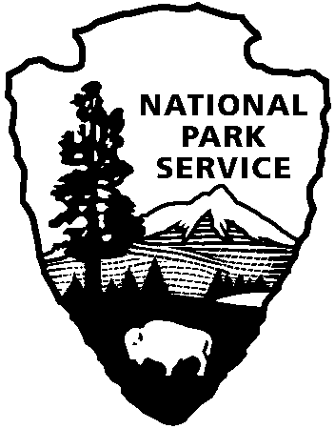

National Capital Parks - East
1900 Anacostia Drive SE
Washington, D.C. 20020
https://www.nps.gov/pisc/index.htm

(202) 690-5185
National Park Service
U.S. Department of the Interior

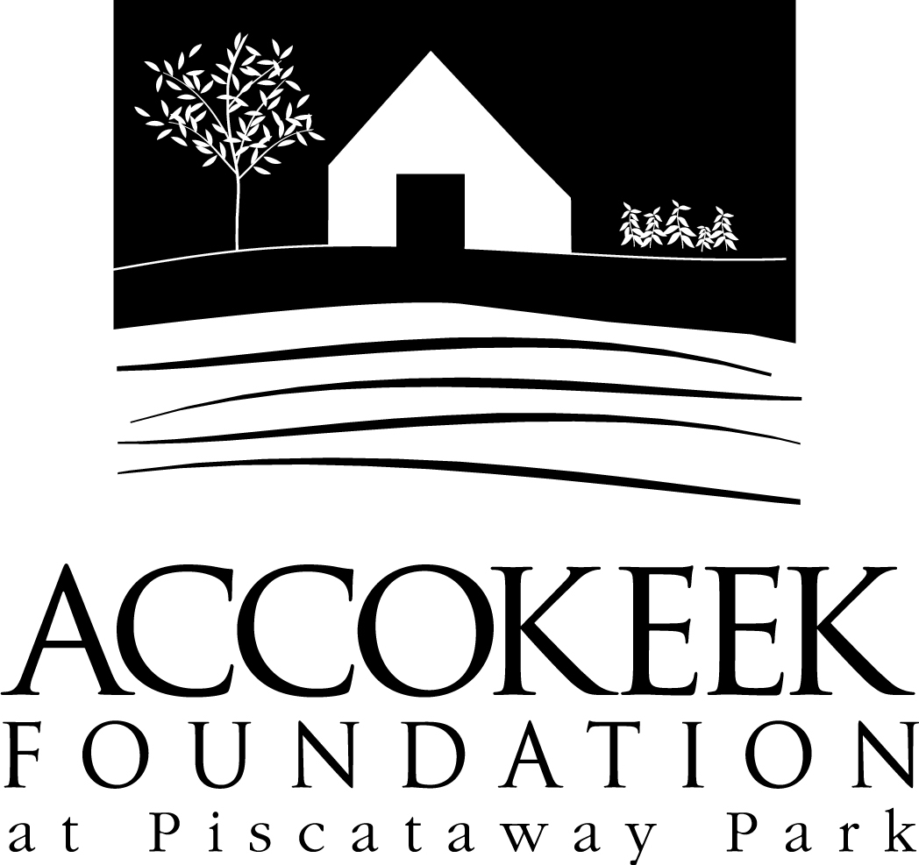

Position Title: Farmhands

About the Foundation:
By blending history, ecology, economics and conservation, the Accokeek Foundation strives to teach land stewardship and sustainable use of natural resources, as well as interpret the natural and cultural heritage of the Tidewater Potomac. The foundation’s mission is to cultivate passion for the natural and cultural heritage of Piscataway Park and commitment to stewardship and sustainability. The National Colonial Farm and other Foundation activities exemplify the agricultural, preservation and conservation goals that are at the core of the Foundation’s mission and serve as an outdoor classroom to further the educational programs that are key to its success. In partnership with the National Park Service, the Accokeek Foundation stewards a 200-acre portion of Piscataway Park and preserves the view directly across the Potomac River from Mount Vernon.

About National Capital Parks - East:
The administrative National Park Service unit of National Capital Parks – East (NACE) contains thirteen park units and parkways, including Piscataway Park. The overall unit consists of 98 locations and more than 8,000 acres of recreation areas, historic homes, natural areas, farms, parkways, historic forts, archeological sites, and private properties. The sites provide important green and recreation space amongst dense urbanization and educate visitors through stories and the historical information related to the area.

About the Heritage Livestock Preservation Program:
The heritage livestock program is part of the Accokeek Foundation’s stewardship of Piscataway Park. We care for our livestock in a way that enhances the health and stability of the natural and agricultural ecosystems of this special place. The heritage breeds of livestock we manage are American Milking Devon Cattle, Hog Island Sheep, Ossabaw Hogs, and Icelandic Chickens.

Position Summary and Purpose:
The Farmhands program was created to assist the livestock manager with feeding, barn maintenance, fence work, general animal care, and various other projects related to the success of our heritage livestock program. This position is a great opportunity to work closely with animals and other dedicated livestock volunteers to support our rare and heritage breeds.

Duties may include:
- Feeding,
- Cleaning/organizing the barn,
- Repairing livestock fencing,
- Clearing brush,
- Maintaining pasture and barnyard areas
- Interacting with the public visiting the site to teach them about our heritage breeds, livestock programming, and answer any questions they may have.
- Lifting loads up to 50 lbs (feed, hay, straw, etc.).

Qualifications:
No previous experience is necessary, but volunteers must be comfortable working around large animals and animals with horns. Experience with 4H, animal husbandry, animal farming, and/or heritage breeds is a bonus.

Time Requirements:
This is a regular volunteer position. Shifts are weekly, and depend on activities/supervisor schedule. Scheduling is somewhat flexible and volunteer activities for each day may be weather dependent.

Benefits:
Volunteers will receive a 10% discount at the visitor’s center.

Volunteers will also be enrolled in the National Park Service – wide Volunteers – In – Park (VIP) program by signing Volunteer Service Agreements. The VIP program protects those volunteering on National Park Service land in case of accident or injury through the Federal Employees’ Compensation Act and the Federal Tort Claims Act. Additionally, for every 250 hours served, volunteers are eligible to receive the America the Beautiful interagency pass which covers entrance fees to more than 2,000 federal recreation sites, including national parks and wildlife refuges, for one year.

Supervisor: Alison Bode, Livestock Manager.

To Participate: Please contact Kaylin Beach, at volunteers@accokeek.org.

