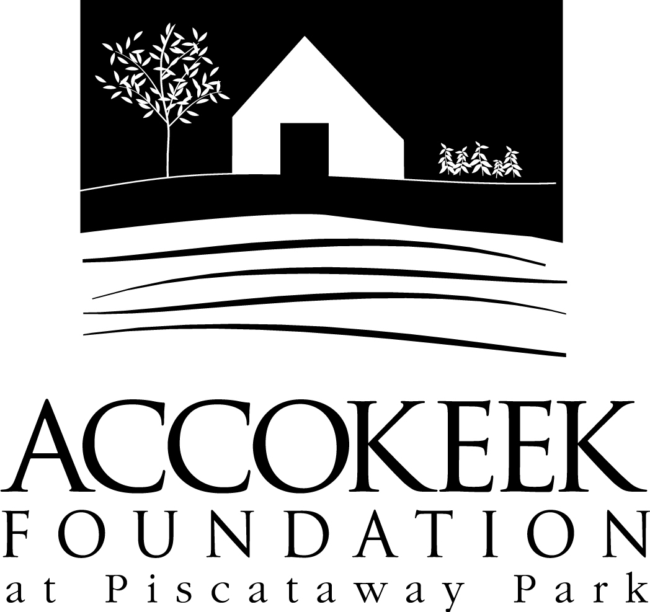

Position Title: Shoreline Clean Up Volunteer
About the Foundation:
By blending history, ecology, economics and conservation, the Accokeek Foundation strives to teach land stewardship and sustainable use of natural resources, as well as interpret the natural and cultural heritage of the Tidewater Potomac. The foundation’s mission is to cultivate passion for the natural and cultural heritage of Piscataway Park and commitment to stewardship and sustainability. The National Colonial Farm and other Foundation activities exemplify the agricultural, preservation and conservation goals that are at the core of the Foundation’s mission and serve as an outdoor classroom to further the educational programs that are key to its success. In partnership with the National Park Service, the Accokeek Foundation stewards a 200-acre portion of Piscataway Park and preserves the view directly across the Potomac River from Mount Vernon.

About National Capital Parks - East:
The administrative National Park Service unit of National Capital Parks – East (NACE) contains thirteen park units and parkways, including Piscataway Park. The overall unit consists of 98 locations and more than 8,000 acres of recreation areas, historic homes, natural areas, farms, parkways, historic forts, archeological sites, and private properties. The sites provide important green and recreation space amongst dense urbanization and educate visitors through stories and the historical information related to the area.

About the Shoreline Clean Up Program:
This program was developed to help preserve the Potomac River and its biodiversity by helping to remove potential pollutants, specifically litter. Volunteers are needed to help remove trash and debris from the Potomac River shoreline. This is a great opportunity for families, service-learning students, as well as Boy/Girl Scout and other groups. Trash bags and gloves will be provided, as well as training on how to properly dispose of trash; please wear sturdy water-resistant shoes and clothing appropriate for slippery and wet conditions. By cleaning up the shoreline of the Potomac River, we can help improve the ecosystem for all who come into contact with the river.

Position Summary and Purpose:
Grab your friends and family and schedule a special stewardship project to make a big impact at Piscataway Park, without committing to a regular schedule. Improve the health of the Potomac River by spending a morning or afternoon picking up trash along the shoreline of Piscataway Park. A simple and rewarding project with a big impact! This project can be scheduled at any time throughout the year, and is never out of season.

Description of Duties:
- Independently picking up litter from the Potomac River shoreline utilizing the different access points along our shore.
- Documenting peculiar or dangerous items found and reporting them to the Program lead.
- Disposing of trash and recycling in their respective areas on land (trash bag vs. recycling bag).
- All volunteers should check in at the Visitor Center before being directed to a cleanup spot on-site.

Qualifications:
No previous experience is necessary. Training will be provided, as will trash/recycling bags and gloves.

Time Requirements:
This position is very flexible. We welcome regular volunteers into this position, but it is also perfect for one time volunteers or project groups. We recommend setting aside at least 1 hour to clean up an area (we’ll recommend the shoreline access point and you can work until you’re tired or done). This activity can be done with large groups or small ones.

Benefits:
Regular volunteers will receive a 10% discount at the museum gift shop and visitor’s center.

Volunteers will also be enrolled in the National Park Service – wide Volunteers – In – Park (VIP) program by signing Volunteer Service Agreements. The VIP program protects those volunteering on National Park Service land in case of accident or injury through the Federal Employees’ Compensation Act and the Federal Tort Claims Act. Additionally, for every 250 hours served, volunteers are eligible to receive the America the Beautiful interagency pass which covers entrance fees to more than 2,000 federal recreation sites, including national parks and wildlife refuges, for one year.

Supervisor:
Risharda Harley, Natural Resource Coordinator

To Apply:
Please contact Kaylin Beach at volunteers@accokeek.org.

