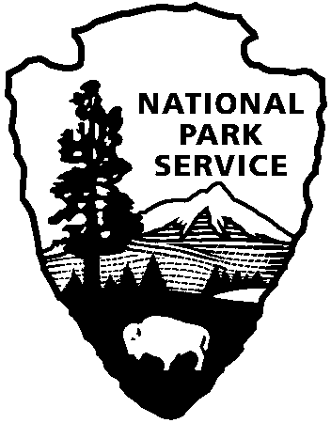

National Capital Parks - East
1900 Anacostia Drive SE
Washington, D.C. 20020
https://www.nps.gov/pisc/index.htm

(202) 690-5185
National Park Service
U.S. Department of the Interior

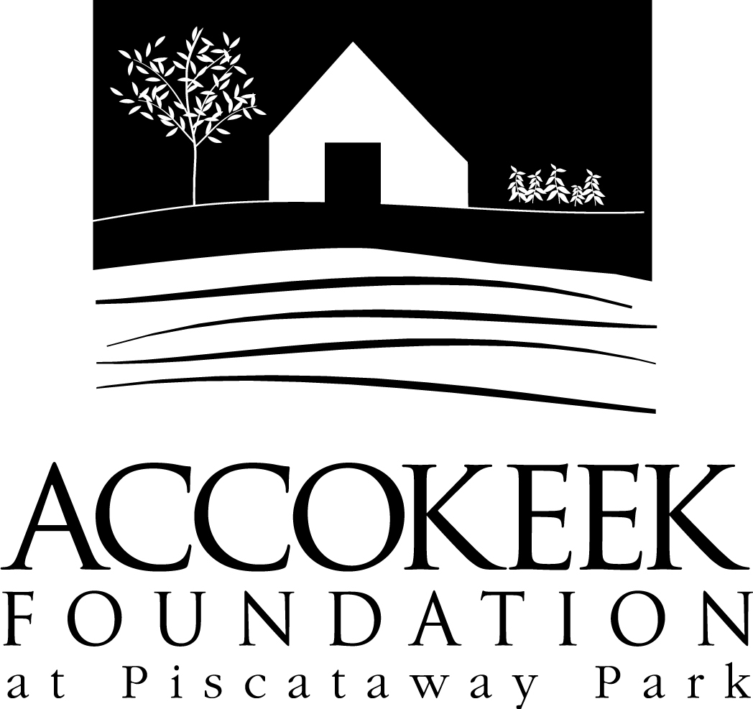

Position Title: Green Thumb Volunteer
About the Foundation:
By blending history, ecology, economics and conservation, the Accokeek Foundation strives to teach land stewardship and sustainable use of natural resources, as well as interpret the natural and cultural heritage of the Tidewater Potomac. The foundation’s mission is to cultivate passion for the natural and cultural heritage of Piscataway Park and commitment to stewardship and sustainability. The National Colonial Farm and other Foundation activities exemplify the agricultural, preservation and conservation goals that are at the core of the Foundation’s mission and serve as an outdoor classroom to further the educational programs that are key to its success. In partnership with the National Park Service, the Accokeek Foundation stewards a 200-acre portion of Piscataway Park and preserves the view directly across the Potomac River from Mount Vernon.

About National Capital Parks - East:
The administrative National Park Service unit of National Capital Parks – East (NACE) contains thirteen park units and parkways, including Piscataway Park. The overall unit consists of 98 locations and more than 8,000 acres of recreation areas, historic homes, natural areas, farms, parkways, historic forts, archeological sites, and private properties. The sites provide important green and recreation space amongst dense urbanization and educate visitors through stories and the historical information related to the area.

About the Green Thumbs Program:
The Green Thumbs volunteer program was created to help support the incredible work of our Crops Farm Manager and team as they endeavor to cultivate and display accurate 18th century gardens, field crops, and build up the health of our park’s soil. Green Thumbs volunteers will have the opportunity to plant seeds of change, both literally and figuratively, as they demonstrate for the general public how important healthy agricultural practices are to the future of our county.

Position Summary and Description of Duties:
Green Thumbs volunteers will work alongside staff to maintain the gardens/fields on the National Colonial Farm, an historic outdoor museum that demonstrates 18th century agriculture. Stepping back in time, volunteers will channel creative ingenuity to utilize traditional agriculture techniques in order to maintain culturally diverse gardens of the past. Among the demonstration areas are the Kitchen Garden, the Colonial Fields, and the Museum Garden.

Responsibilities may include:
- Plant, water, and tend plants
- Monitor plant health and treat for disease, nutrient deficiency, and pests
- Keep gardens and pathways weed free and accessible
- Repair garden fences, gates, and interior structures as needed
- Provide staking, trellising, and other supports to plants as needed
- Maintain compost bins
- Harvest, process, and save seed
- Maintain tools, supplies, and equipment in good working order
- Educating visitors directly or support education of visitors around these agricultural spaces, the history of these plants, and regenerative/sustainable practices (onsite and/or virtually)
- Other applicable duties as assigned

Qualifications:
No previous experience necessary. Training in sustainable and historical agricultural practices will be provided. This volunteer position is ideal for anyone interested in horticulture, gardening, or food history. Opportunities exist for all skill levels. The position requires working outdoors in various weather conditions, bending, squatting, and some lifting. May involve use of mechanical tools such as lawnmowers/weedwackers and hand tools such as hoes/broadforks/shovels/etc...

Time Requirements:
This position is regular, on-going, and seasonal (March-November). Green Thumbs meet every Thursday from 9-12 (weather permitting). As season progresses, shifts may occur on Saturdays as well. At the discretion of the supervisor, volunteers may be offered additional shifts as needs occur. Active Green Thumbs volunteers are expected to serve a minimum of 50 volunteer hours per season (March-November). These hours can be served consecutively or over the course of the full season.

Benefits:
Volunteers will receive a 10% discount at the visitor’s center and have the opportunity to join a community of like-minded individuals and learn valuable skills around gardening, regenerative agriculture, sustainability, culture and history of food, food systems, seed saving, and much more. Green Thumbs volunteers have a private Facebook group to share knowledge and build skills in plant identification, cultivation practices, community sustainability, and more. Volunteers participating in the Green Thumbs team work almost entirely outdoors, experiencing the beautiful natural environment of Piscataway Park. During harvests, Green Thumbs may be able to take home some of the harvested produce at the discretion of the Crops Farm Manager.

Volunteers will also be enrolled in the National Park Service – wide Volunteers – In – Park (VIP) program by signing Volunteer Service Agreements. The VIP program protects those volunteering on National Park Service land in case of accident or injury through the Federal Employees’ Compensation Act and the Federal Tort Claims Act. Additionally, for every 250 hours served, volunteers are eligible to receive the America the Beautiful interagency pass which covers entrance fees to more than 2,000 federal recreation sites, including national parks and wildlife refuges, for one year.

Supervisor: KC Carr, Crops Farm Manager.

To apply: E-mail Kaylin Beach, Volunteer Coordinator, at volunteers@accokeek.org.

