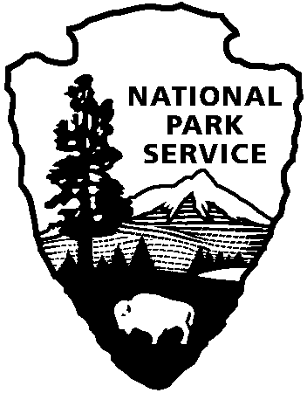

National Capital Parks - East
1900 Anacostia Drive SE
Washington, D.C. 20020
https://www.nps.gov/pisc/index.htm

(202) 690-5185
National Park Service
U.S. Department of the Interior

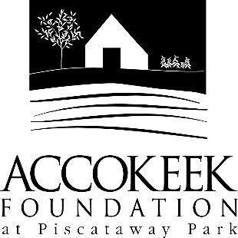

Position Title: Stitch ‘n Time Club
About the Foundation:
By blending history, ecology, economics and conservation, the Accokeek Foundation strives to teach land stewardship and sustainable use of natural resources, as well as interpret the natural and cultural heritage of the Tidewater Potomac. The foundation’s mission is to cultivate passion for the natural and cultural heritage of Piscataway Park and commitment to stewardship and sustainability. The National Colonial Farm and other Foundation activities exemplify the agricultural, preservation and conservation goals that are at the core of the Foundation’s mission and serve as an outdoor classroom to further the educational programs that are key to its success. In partnership with the National Park Service, the Accokeek Foundation stewards a 200-acre portion of Piscataway Park and preserves the view directly across the Potomac River from Mount Vernon.

About National Capital Parks - East:
The administrative National Park Service unit of National Capital Parks – East (NACE) contains thirteen park units and parkways, including Piscataway Park. The overall unit consists of 98 locations and more than 8,000 acres of recreation areas, historic homes, natural areas, farms, parkways, historic forts, archeological sites, and private properties. The sites provide important green and recreation space amongst dense urbanization and educate visitors through stories and the historical information related to the area.

Purpose of Stitch ‘n Time:
The Stitch ‘n Time club is a volunteer-based textiles club where members process fibers from the farm and maintain the foundation’s inventory of colonial clothing. The club was initiated to fill the need for instruction in the disappearing skills of textile work, such as handspinning, weaving, hand-sewing, and hand-processing wool, while also drawing attention to critically endangered heritage breeds such as the Hog Island Sheep. Club participants are taught a variety of textile skills and educate the public through demonstrating those skills in an instructionally hands-on way. Completed club projects are sold during special events and at the Visitor Center, with proceeds supporting our Heritage Livestock Breeding Program.

Position Summary and Description of Duties:
Using mostly wool from the foundation’s Hog Island Sheep flock, cotton grown in the Museum Garden, Red May Wheat and Linen Flax grown in the National Colonial Farm Fields, club members work through every step of fiber processing, including: washing/retting, carding/beating, dyeing, spinning, weaving, knitting/crocheting. Club members also help to create and mend clothing worn by the foundation’s interpretive staff during educational events on the National Colonial Farm. During special meetings throughout the year, members may also complete additional projects such as weaving and felting. Clubbers act as educators, demonstrating their skills and instructing the general visitor on the steps of fiber processing and the value of heritage breeds such as Hog Island Sheep.

Responsibilities may include, but are not limited to:
- Washing, carding, dyeing, spinning, and knitting/crocheting, retting, beating, weaving, felting,
- Creating 18th century clothing for interpretive staff using patterns, drafting patterns,
- Mending 18th century clothing;
- Participating in/leading educational programs and events.
- Supporting fleece and fiber sales through marketing, prep, mailing.

Qualifications:
No previous experience is necessary. Stitch ‘n Time accepts all skill levels, from novice to expert. Club meetings are a great place to learn and hone fiber arts skills.

Time Requirements:
To be an active member of the club, Stitch ‘n Time members are expected to log at least 20 hours a year. The club meets on the fourth Saturday of every month, 1-4 pm. Club members are expected to attend as many meetings as possible. Club members may also take home projects to work on between meetings. Club members are responsible for keeping a log of hours volunteered outside of meetings and submitting that log to the Foundation for recording. At the discretion of the staff, club members may choose to attend meetings or take home work depending on availability. Other shifts/opportunities to engage may be offered, or extended meetings.

Benefits:
Volunteers receive a complimentary membership to the Accokeek Foundation, which includes discounts on classes and events, a 10% discount in the Visitor Center, invitations to member and volunteer events, a discount on facility rental rates, and a copy of the newsletter.

Volunteers will also be enrolled in the National Park Service – wide Volunteers – In – Park (VIP) program by signing Volunteer Service Agreements. The VIP program protects those volunteering on National Park Service land in case of accident or injury through the Federal Employees’ Compensation Act and the Federal Tort Claims Act. Additionally, for every 250 hours served, volunteers are eligible to receive the America the Beautiful interagency pass which covers entrance fees to more than 2,000 federal recreation sites, including national parks and wildlife refuges, for one year.

Supervisor: Kaylin Beach, Volunteer Coordinator and Museum Educator

To Apply:
Please contact Kaylin Beach at volunteers@accokeek.org.

